This week’s focus:  What is 4? | Maths inputs
Monday | Introduce the number line to 4. Sing Hey Numbers song and teach the children where to look for the numbers on the number line. Count forwards and play games removing a number at a time whilst the children’s eyes are closed to see if they can spot the missing number. Match amounts to numerals, for example, 1 jump, 2 spins, 3 claps etc.  https://whiterosemaths.com/homelearning/early-years/light-and-dark-week-1/ Watch Session 1. Complete the activity below.
Tuesday | Number line the same as yesterday.  Have a basket of one object that is engaging to count (shells, cars, buttons etc). Can you count out 4 items and arrange them on the floor? How many are there altogether? Does your four look the same as mine? Rearrange the items. How many are there now? Can you make yours look like mine? Can you arrange your pattern to look different to mine?  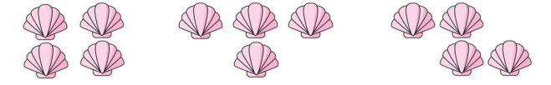
Wednesday | Number line the same as yesterday.  Have something engaging to count like in yesterday’s lesson. Can you count out 4 items and put them in a row? What happens if we take one away? How many are left? One less than 4 is 3. What happens is we add one more? How many do you have? One more than 3 is 4. Use the 5 frame below. Put 4 objects on the 5 frame. What do you notice? (there is one space left) 4 is one less than 5 and so there will always be a space. Use the 5 frame to explore one more and less with amounts up to 4.
Thursday | Number line the same as yesterday.  https://www.youtube.com/watch?v=MwjibIsXUr4 Watch the Number blocks video all about 4.  Fill a bag with up to 4 objects and close. Get the children to feel the objects and see if they can count how many are inside. Check by emptying the bag and counting the objects carefully. Repeat by changing the amounts in the bag. How many objects can you feel in the bag? If I take one out how many will there be? If I add one how many will there be? How many are there now? How do we check? Play a game against an adult. Take it in turns to feel the amounts in the bag and count. If you count correctly you score a point. The player with the most points wins!
Friday | Number line the same as yesterday.  Play a circle game counting 1,2,3,4. Place as many objects as you can in a circle (teddies, dolls, cars, dinosaurs). Go round the circle counting up to 4 (1,2,3,4) and take away the fourth object each time until you are left with one at the end.

Monday:

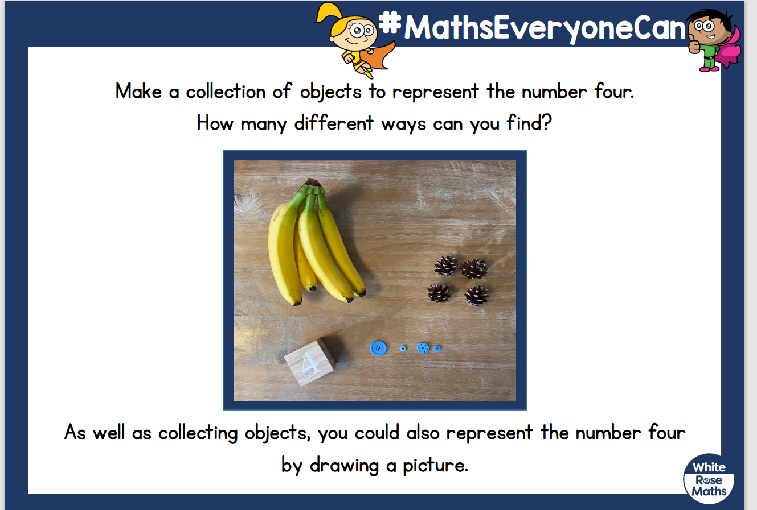

Tuesday:

