WC: 30/11/20 | Monday | Tuesday | Wednesday | Thursday | Friday
Maths | Show you child the picture of the greedy elf. Tell them that this elf is very hungry and that we need to feed him. Model pretending to feed the elf food from your kitchen. Tell your child that the elf always asks for more. Can we feed it more? What does more mean? | Set up a tea party with some of your children’s toys or teddies up to 5. Using pretend food or playdough ask your child to give each toy/ bear a bun (make sure they aren’t enough for all the toys/ bears beforehand). What happens when your child shares them out? Do they notice that we don’t have enough? What do we need? We need more. | Let your child help you make a meal today (breakfast, a snack, lunch etc.). Make some drinks and deliberately make sure that there isn’t going to be enough for all of the glasses. If you are making a bowl of cereal make sure that there is only enough for 1 bowl of cereal. What do we need? We need more. We are encouraging the children to understand when there isn’t enough. | Santa has delivered some presents today for all the children (see presents and children below). Can you make sure that each child has a present to open?  What does your child notice? Is it fair? What do we need? | Using bowls and rice/ pasta give your child a small bowl and ask your child to fill it with all the pasta or all the rice (make sure it is far too much rice/ pasta for the bowl). What’s happened? What does your child notice? Is there enough rice/ pasta? Do you need more rice/ pasta? Is it too much rice/ pasta for the bowl? Introduce the vocabulary too much and explore what this means within different contexts. For example, too much water in the glass or too much food on a plate etc.
Phonics/ circle times | Read The Gingerbread Man or watch it on Youtube: https://www.youtube.com/watch?v=pckuS--UlV4  Encourage your child to listen to the repeated phrases, the intonation in your voice and the rhythm of the language. Can your child join in and jump in with the repeated phrases? | Read Brown Bear, Brown Bear or watch and listen to it on Youtube: https://www.youtube.com/watch?v=WST-B8zQleM  Encourage your child to listen to the repeated phrases, the intonation in your voice and the rhythm of the language. Can your child join in and jump in with the repeated phrases? Can your child hear any words that rhyme? | Join in with Shonette Bason’s Dough Disco: https://www.youtube.com/watch?v=3K-CQrjI0uY. You will need a small amount of playdough for this. | Mark making-  Can your child draw a picture of your family? Who is in your family? Ask your child to tell your what their marks represent. Can your child make marks/ letters to represents their name to label themselves? | Sing Hickory Dickory Dock and ask your child to listen carefully for the words that rhyme.  Hickory dickory dock. The mouse went up the clock  The clock struck one. The mouse went down  Hickory dickory dock  Tick tock, tick tock, tick tock, tick tock.  You could even add more verses into this rhyme with different animals, for example, a snake, an elephant, a cat etc.
Communication and Language | Watch and listen to story: Dear Santa: https://www.youtube.com/watch?v=FnQFjdJ-7XI  - Can you predict what the item is based on the description?  - What would you ask Santa for? |  |  | Watch and listen to: Father Christmas Needs a Wee: https://www.youtube.com/watch?v=f3DSRbHwTb4
Additional activities | Can you make a Christmas list for Santa using pictures from catalogues/magazines? Can you send it to Santa ready for Christmas? Don’t forget to write your name on the bottom so that he knows who it is from. | Listen to Dear Santa again. Can you change some of the presents in the story?  Using these describing words what else could Santa send?  -Something too small;  -Something too big;  -Something too bouncy;  -Something too scary;  -Something too messy;  -Something too noisy;  -Something you want for Christmas. | Yoga with Rebecca and Duggee: https://www.bbc.co.uk/cbeebies/watch/yoga-with-rebecca-and-duggee | Wrap up some parcels/ boxes for Santa’s workshop (different sizes and weights) Ask your child to guess what could be inside. What shape is it? Is it heavy or light?  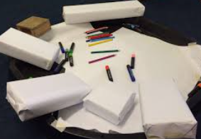 | Make some green playdough and using a tree cutter or different tools create a Christmas tree shape. Can you decorate your tree with decorations such as buttons, stars, tinsel, pom poms etc.?  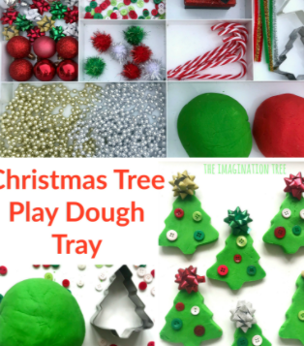

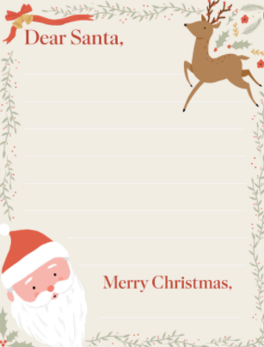

Maths- Greedy Elf

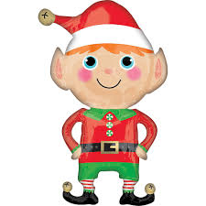

Maths- Santa, his presents and the children.

