WC: 23/11/20 | Monday | Tuesday | Wednesday | Thursday | Friday
Maths  We are going to be looking at different concepts this week. | Big and small.  Talk about what is big compared to small. Can your child make a big item with the play dough and a small item, for example, big heart and a small heart. What do they notice about the size differences? | Slow and fast.  Go outside and talk about what slow is and fast. Can your child run really fast and then change to slow? Repeat using a variety of actions in fast and slow motion, for example, fast walking/ slow walking or fast clapping slow clapping. | Full and empty.  Explore water in the water tray or washing up bowl. Can your child fill a container until it is full? This could be a cup or even an empty water bottle. What happens when they pour all the water out? What do they notice? Can they use the terminology full and empty? How many cups of water does it take to fill up the water bottle? | Hot and cold.  Explore the differences between hot and cold. For example, warm water and freezing cold water, hot toast and cold toast, warm hot chocolate and freezing cold chocolate. Does it feel different when something is hot to cold? | Old and Young  Look at a range of pictures of young and old people (see photographs below) and talk about which ones are old people (grey hair) and which ones are young (babies and small children). How do they know who is old and who is young (differences)? Talk about every year your child (and everyone else) has their birthday and every year you all get 1 year older. How old will your child be on their next birthday?
Phonics/ circle times | Watch and listen to: https://www.youtube.com/watch?v=8ULe4kt4CGA  Rhyme Crime.  Listen to it again and stop it to listen to the words that rhyme in the story. | Watch and listen to: https://www.youtube.com/watch?v=NomrLEzapAM  Pass the Jam Jim.  Listen to it again and stop it to listen to the words that rhyme in the story. | Join in with Shonette Bason’s Dough Disco: https://www.youtube.com/watch?v=3K-CQrjI0uY You will need a small amount of playdough for this. | Rhyming Bingo  Play rhyming bingo with the pictures below. Give your child 3 pictures and put the matching rhyming picture in a bag. Draw out a picture, say what it is and match it to the picture that rhymes. | Rhyming Pairs  Play rhyming pairs using the pictures from yesterday. Place them down on the floor, turn two over and see if they rhyme. If they are not a rhyming pair then place them back down. If they do rhyme then keep them.
Communication and Language | Watch and listen to story: What the Ladybird Heard https://www.youtube.com/watch?v=ZfBG7roy1cA  - What rhyming words could you hear?  - Can you think of a word that rhymes with these words, mad, log, dig, toy, den? |  |  | Watch and listen to: Number songs and rhymes https://www.bbc.co.uk/cbeebies/watch/number-songs-from-numberblocks?collection=playlist-collection
Additional activities | Using the playdough recipe below, make some red and black playdough. Make some ladybirds with dots to match numerals/ dots to 5.  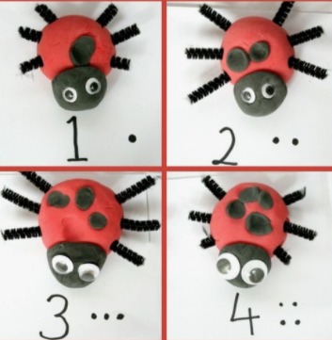 | Using the pictures below, cute them out and create puppet sticks to retell the story. Can you make the animal noises? | Joe Wicks workout: https://www.youtube.com/watch?v=d3LPrhI0v-w | Can you make up a song which includes lots of examples of animal sounds?  Watch this example: https://www.youtube.com/watch?time_continue=81&v=7NbyiDpY6Ww&feature=emb_title  You could change the animals on Old Macdonald? | Collect objects from around your home and create a rhyming basket. Take it in turns to pull out an object and find another object that rhymes with it.  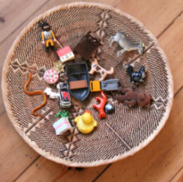

Maths- young and old photographs

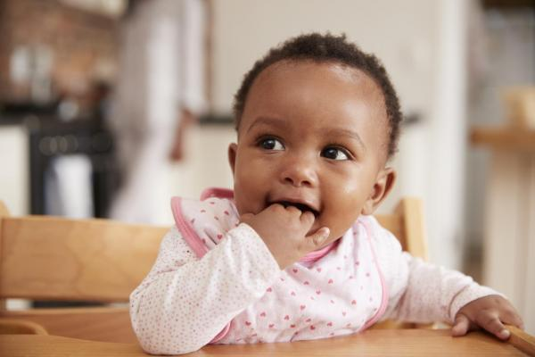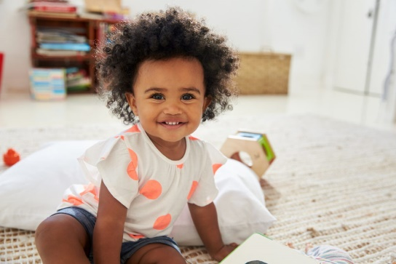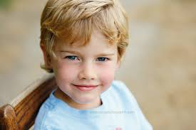

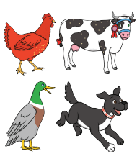
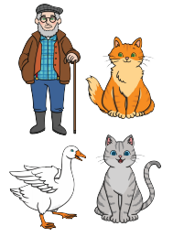
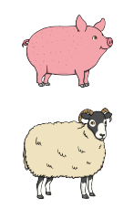
Thursday and Friday:

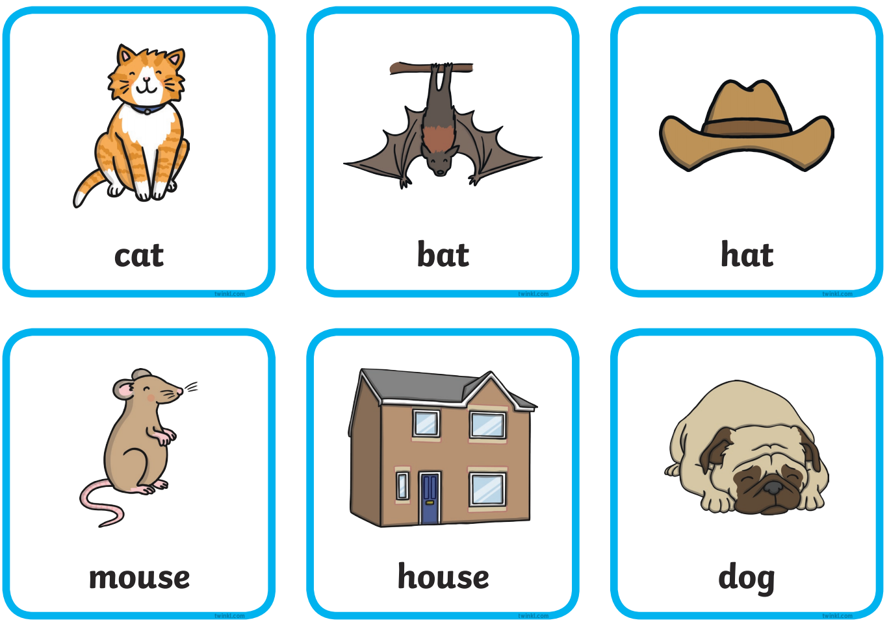

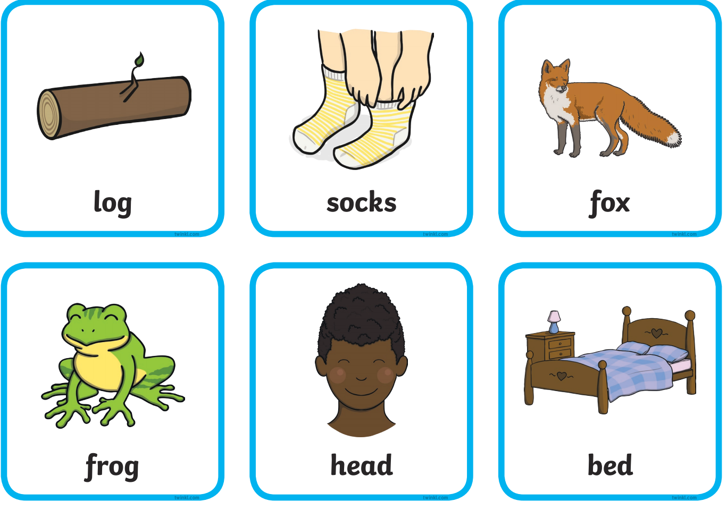

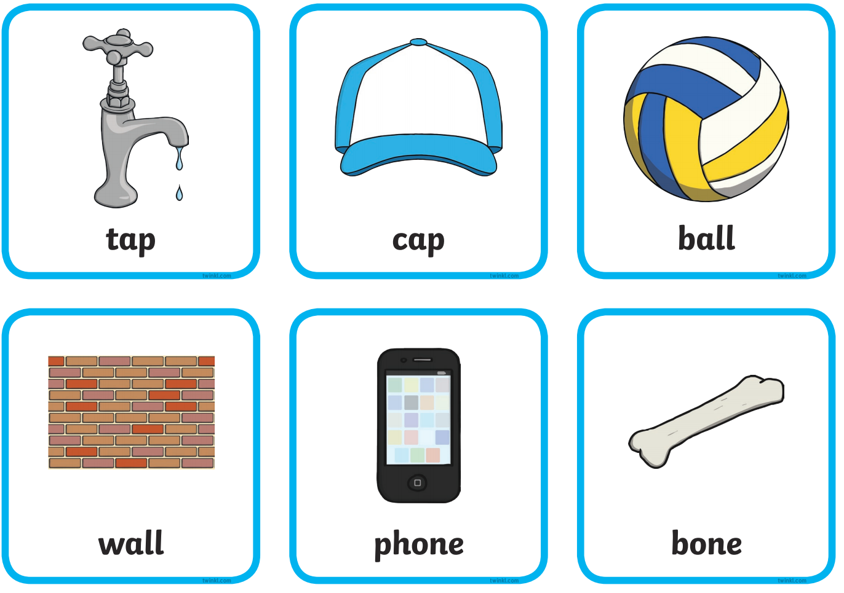
Playdough recipe:
