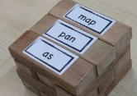

Word Jenga

Write some cvc words on pieces of paper and attach to the Jenga bricks. Build the Jenga tower and then take it in turns to remove one brick at a time each. Each time a brick is removed successfully without the tower toppling over, read the word.

You could even try this game with tricky words.

