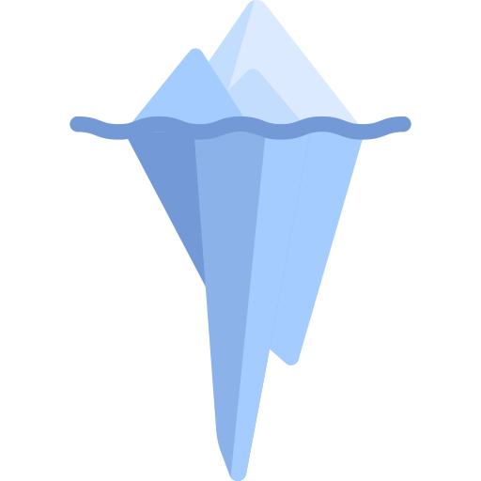

**Glacier prediciton**

**Glacier prediciton**

What will happen when the ice melts?

_________________________________________________________________________________________________________________________________________________________________________________________________________________________________________________________________________________________________________________________________________________________________________________

What will happen when the ice melts?

_________________________________________________________________________________________________________________________________________________________________________________________________________________________________________________________________________________________________________________________________________________________________________________