Pack 11 and 12 – Wider Afternoon Curriculum

'Chocolate'

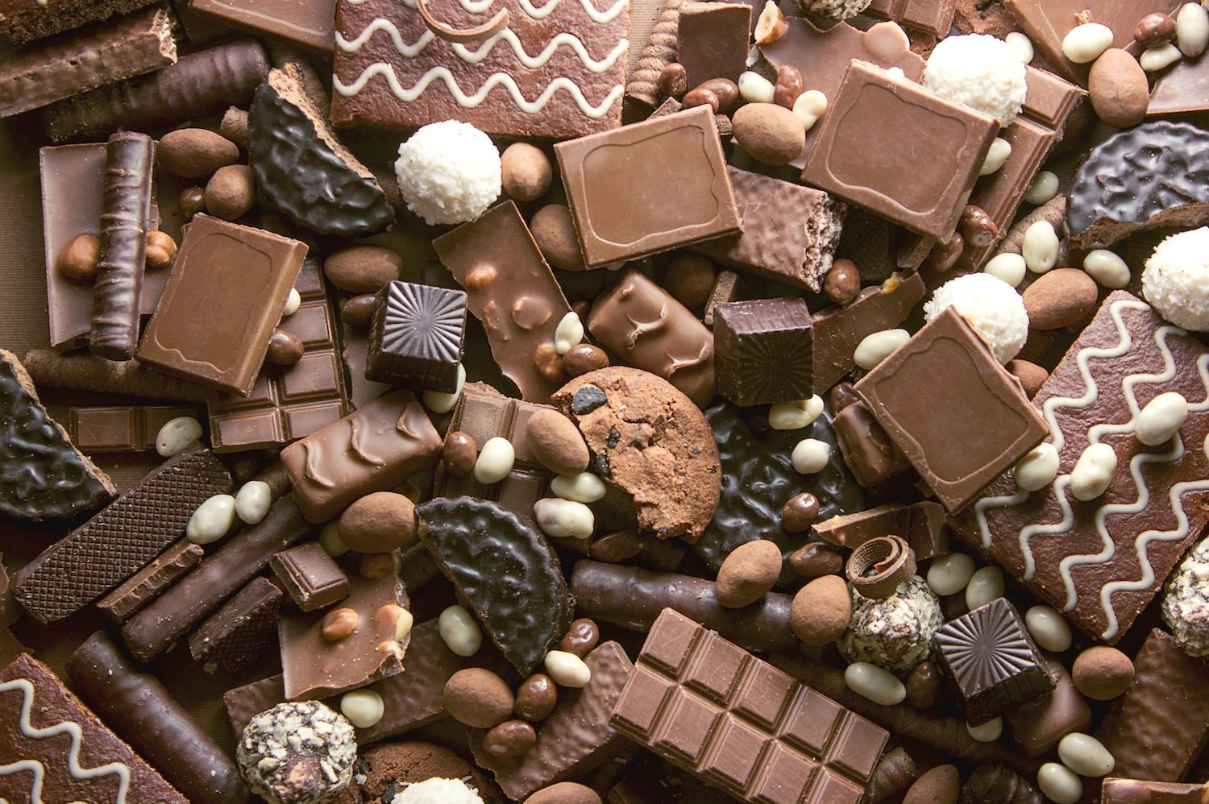

Please share your activities on Twitter @RokebyPark #rokebyparkhomelearning
 | Suggested Activity
1 | Geography: Where does chocolate come from? How is it made?  https://www.youtube.com/watch?v=zJdeQABAc_w  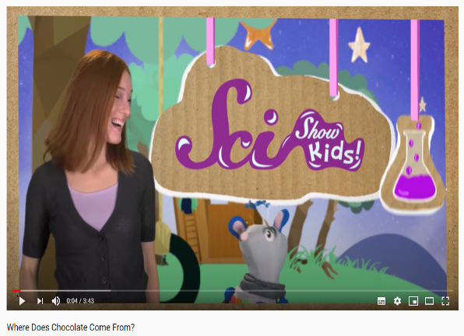  We would like you to get creative with this: you might want to make a poster or draw a map of the countries where cacao trees grow. You might want to make your own cacao tree using different materials in your home or draw a timeline of how chocolate gets from the bean to the shops! It’s up to you! Don’t forget to write the important information down on how chocolate is made!
2 | Design & Technology:  Willy Wonka would like a new chocolate bar. Can you help him design one? Design- What flavour chocolate? What will it look like? What will the wrapper look like? Will it have anything extra like sweets or jellies in it? Draw and label your design. Make- You could try making your own chocolates. With the help of a grown-up, melt some chocolate in a bowl and then use a jelly mould or ice cube tray to create some new shapes. Evaluate- Did it work? What went well? What didn’t go so well? Was anything difficult for you to do? If you made some more chocolates, what would you do differently next time? Write a small evaluation for your chocolate bar.
3 | PSHE: Healthy Eating  It’s very important to have a balanced diet. Do you know what a balanced diet is? It’s okay for us to eat sweets, chocolate, ice creams, crisps and fizzy drinks but we should try not to have too many. We can call these our ‘sometimes’ foods. We also have healthier foods like fruit and vegetables. These are really good for us and it’s great to eat as many fruit and vegetables as we can. It’s also important to drink lots of water. Can you design a healthy breakfast, dinner and tea for Willy Wonka? Draw and label his plates so he knows what to cook.
4 | Art and Design:  Can you create your own chocolate factory? You could draw and label your chocolate factory on a big piece of paper or you could make one using card and resources you have in your house. There’s lots to add to your factory. Think about these things: What will be in your factory? How many people will work there? Can you make tickets for visitors? What time is your factory open? How much is it to visit your factory? What are the golden rules in your factory?
5 | Art and Design:  Create your own 'golden ticket' that adults and children have to try to find in chocolate bars to come to your factory.  Be as colourful and creative as possible!
6 | Geography and Science:  Create a map of your chocolate factory or even your own chocolate world.  Can you add a compass on it with the directions north, south, east and west so your visitors don't get lost?  Think about the seasons and the weather. Can it be really hot in your own chocolate world? What might happen to the chocolate if it is really hot? Would it be okay if it was really, really cold in the coldest winter?

