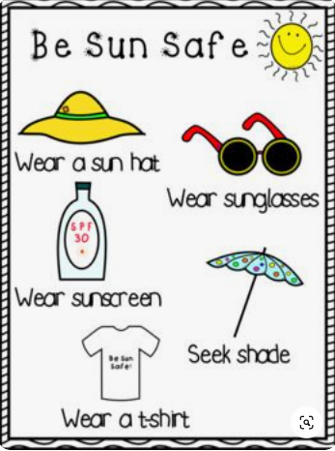
Sun Safety

Talk about keeping safe in the sun.
What can you do to keep safe?
Why do we need to protect ourselves from the sun?

Design a poster/ a creation about sun safety and send a picture of it to our Rokeby Twitter page using the #rokebyparkhomelearning.
There will be a competition for the best, most creative sun safety poster/ creation. The deadline is Friday 3rd July 2020.

