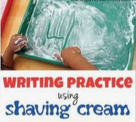

Shaving Foam Writing

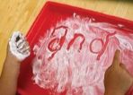

Squirt shaving foam or place hair gel on a tray or plate. Encourage your child to write some tricky words in the material.

Can your child write some the words that they have learnt in phonics this week?