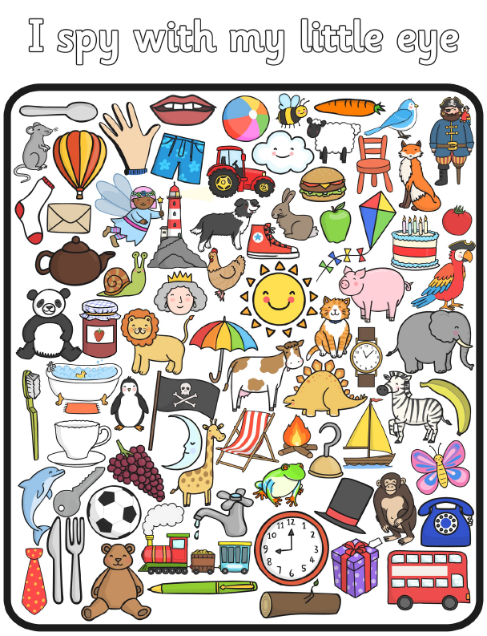

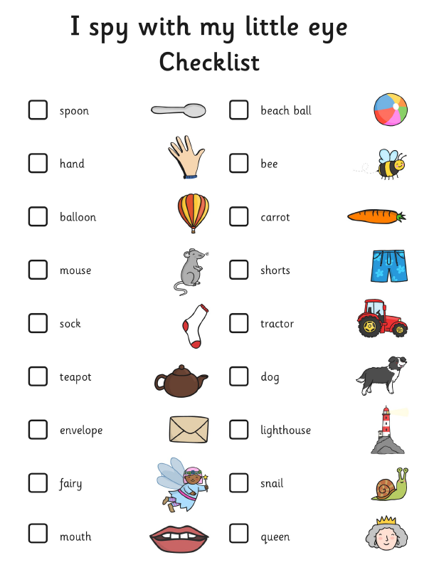

**Initial sounds**

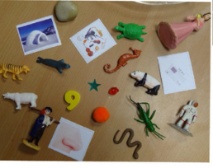

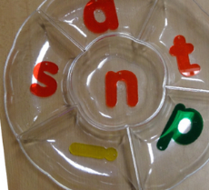

* Collect objects from around you home that begin with m, a and s to begin with. Remember these need to be pure sounds.
* Talk to your child about these objects and practise saying the object name and placing emphasis on the initial sound, for example, mmm mouse
* Support your child to sort these objects according to their initial sounds.

**Silly Soup- rhyming words**

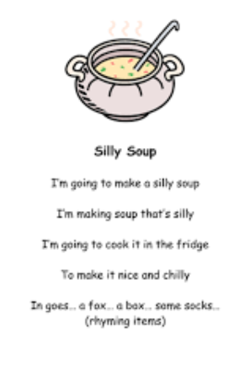

Collect real objects from around your house, if possible.

Ideas of things that rhyme:

* Fox and socks;
* Cat and hat;
* Bin and tin;
* Pear and bear;
* Duck and truck;
* Mouse and house;
* Car and jar;
* Pan and fan;
* Rice and dice.