A Magical Muddle – Guided Reading Pack 11 and Pack 12

These activities are planned to improve a child’s understanding of a text through comprehension activities. Some children will need support when reading this text. If your child is finding any of these activities difficult don’t worry! You can talk through them or you can use your child’s own home-school books and ask simple questions from there instead.

Day | Activities – Pack 11
Monday | Read the title of the book and the blurb on the back.  Using this and the pictures on the front cover, can you write a sentence to tell me what you think will happen in the story?
Tuesday | 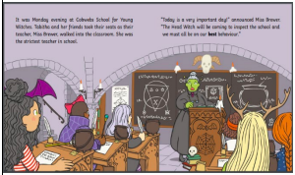  Read the first two pages of the story together and answer the following questions.  1. What day was it?  2. What is the class teacher’s name?  3. Why is today important?  4. What do the witches need to be?
Wednesday | 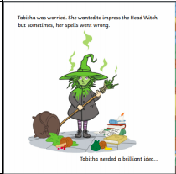  Read the next page together.  On page 3 it says, “Tabitha needed a brilliant idea…”  Without looking at the next page, can you write a write a sentence telling me what you think her brilliant idea will be?
Thursday | 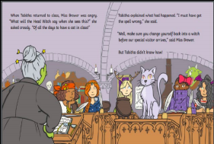  Read up to page 8 together.  Tabitha has accidentally turned herself into a cat! Now it’s your turn…  What animal would you turn yourself into and why?  Draw a picture of the animal you would like to turn into and write a sentence telling me why you want to be that animal.
Friday | Answer these questions based on what we’ve read so far.  1. What has Tabitha turned herself into?  2. What was the name of the spell that Tabitha wanted to use to impress the Head witch?  3. How did Miss Brewer feel when Tabitha returned to class?  4. Why do you think Miss Brewer felt angry?

Day | Activities – Pack 12
Monday | 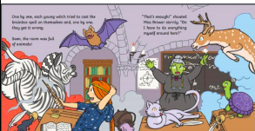  Read to the end of page 18 together.  Write a character description for one of the animals you can see?
Tuesday | 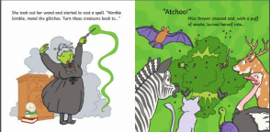  Read page 19 and 20 together.  Write a sentence to tell me what you think Miss Brewer will turn into using clues off these pages.
Wednesday | Read page 21 together and answer these questions.  1. What did Miss Brewer turn into?  2. How do you think Miss Brewer feels when she sees the Head Witch?  Read to the end to the story together.  Do you think Tabitha will offer to turn the Head Witch into a unicorn? Why?
Thursday | At the end of the story Tabitha says, “I could give it a try”.  Think of a time when you did something for the first time and or when you tried to do something that you knew would be hard.  Write a sentence telling me what you did and how it made you feel.
Friday | Book Review  Write one sentence telling me what you liked about the story.  Write one sentence telling me what you did not like about the story.

