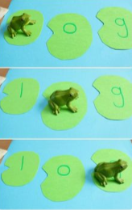

Frog Lily Pad Blending

Create some lily pads with letters on. Place the lily pads next to each other and using a frog figure, model jumping on the lily pads and sounding out the word. For example, m-a-d mad. You could do this cars stopping at different places or even dinosaurs jumping in muddy puddles.