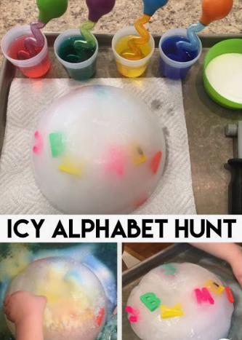

Icy Letter Hunt

Place some magnetic letters in a bowl of water and freeze it. Children can then explore how to save the letters from the ice. Talk about how water turns into ice and how it can be melted. Once the letters have been saved, talk about the letter names and the sound the letters makes.