Doubling Tens Frames

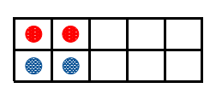

is

Double

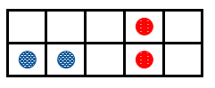

is

Double

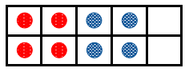

is

Double



Double

is



is

Double



is

Double