Crime and Punishment

Roman Crime and Punishment

The Romans had a complex system of government and laws. Many of the basic systems and ideas that we have about laws and government today comes from Ancient Rome.
Who made the laws?
Laws were made a number of different ways. The primary way of making official new laws was through the Roman Assemblies. Laws were voted on by citizens who were members of the assemblies. There were other ways, however, that laws were implemented including the Plebeian Council, decrees by the senate, decisions by elected officials (magistrates), and edicts by the emperor.
Who enforced the laws?
The laws were enforced by an official called the praetor. The praetor was the second highest ranking official in the Roman republic (after the consuls). The praetor was responsible for the administration of justice.
To keep the laws in the city, the Romans had a police force called the Vigiles. The Vigiles dealt with petty criminals like thieves and runaway slaves. When more force was needed, like during riots or against gangs, other more military groups were used such as the Praetorian Guard and the urban cohorts.
Roman Constitution
The Roman Constitution was an agreed upon set of principles that was followed by the Roman government. It wasn't written down in one place, but was established through tradition and individual laws.
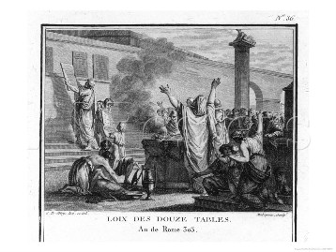
Law of the Twelve Tables
by Silvestre David Mirys
The Law of the Twelve Tables
Because many of the laws were unwritten or unavailable for the people to see, there was much room for corruption by public officials. The people eventually revolted against the leaders and, in 450 BC, some laws were written on stone tablets for everyone to see. These laws became known as the Law of the Twelve Tables.
Roman Citizens
Many of the protections and rights given to people under Roman law only applied to Roman citizens. It was a big deal to be a full Roman citizen. There were even different levels of Roman citizenship, each one having more or less rights than the next.
Punishment and Prisons
The punishment for committing a crime in Rome was not the same for everyone. What punishment you received depended on your status. If you were a wealthy patrician you would receive far less punishment than a slave would for the same crime.
Punishment could include beatings, lashings, exile from Rome, fines, or even death. The Romans generally didn't send people to prison for crimes, but they did have jails to hold people while their guilt or punishment was determined.
Legacy of Roman Law
Many aspects of Roman law and the Roman Constitution are still used today. These include concepts like checks and balances, vetoes, separation of powers, term limits, and regular elections. Many of these concepts serve as the foundations of today's modern democratic governments.
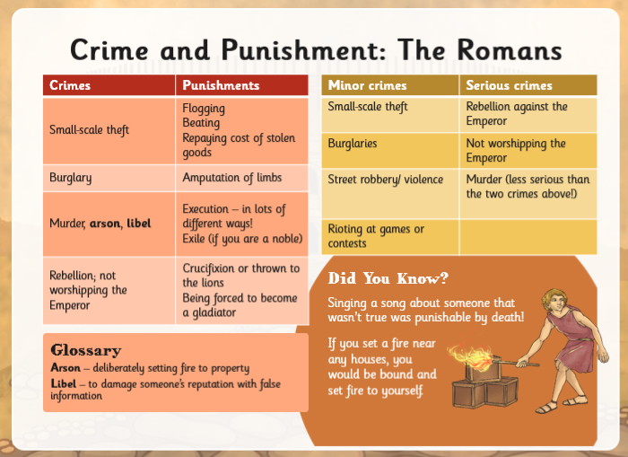

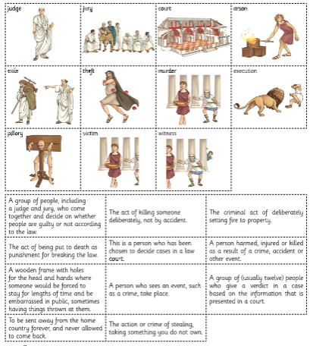
Task: Match the descriptions to the pictures and then can you sort them into the following categories:
- people
- crime
- punishment

- Which of the punishments
still happen today?
- Why do you think it’s different now?
- Did the Romans have a fair system to punish people? Think about the difference between whether you were a slave or a noble.

Anglo-Saxon Crime and Punishment
Follow this link: https://www.slideshare.net/DHUMPHREYS/crime-and-punishment-in-anglo-saxon-england
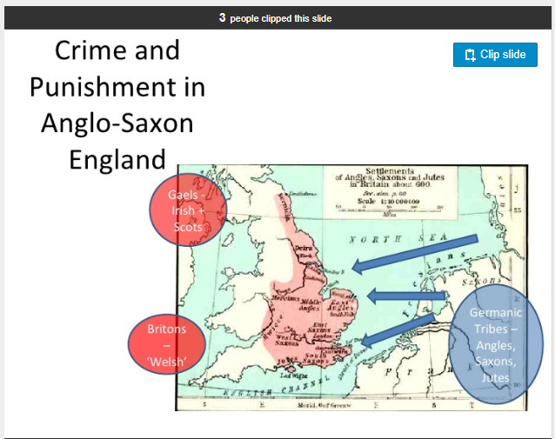
The Anglo-Saxons had brutal corporal and capital punishments at their disposal, including ‘the ordeal’ and grisly mutilations. Like many traditional societies, the Anglo-Saxons placed a high value on a person’s word, their sworn promise.
At the heart of the tenth-century state was the oath, taken by all freemen from the age of 12, to promise not to commit any major crime. This common oath enshrined the sense of social community and responsibility that underpinned the law. In this light, theft was seen as an act of disloyalty. If you had broken your oath and committed a serious crime your entire family could be punished.

Trial by ordeal
Trial by Ordeal was a way to decide if someone is guilty or innocent of a crime. This was usually done by causing the accused person to do a task that was painful. If that task was completed without injury or if the injuries healed fast, this was usually taken as a sign of God, which meant that the accused was innocent.
People believed that God would not allow the innocent to be harmed. He would therefore help them by doing a miracle. is magical rather than invocation of a deity’s justice.

Watch this YouTube video:
https://www.youtube.com/watch?time_continue=1&v=ZTzh1oT0b_8&feature=emb_logo
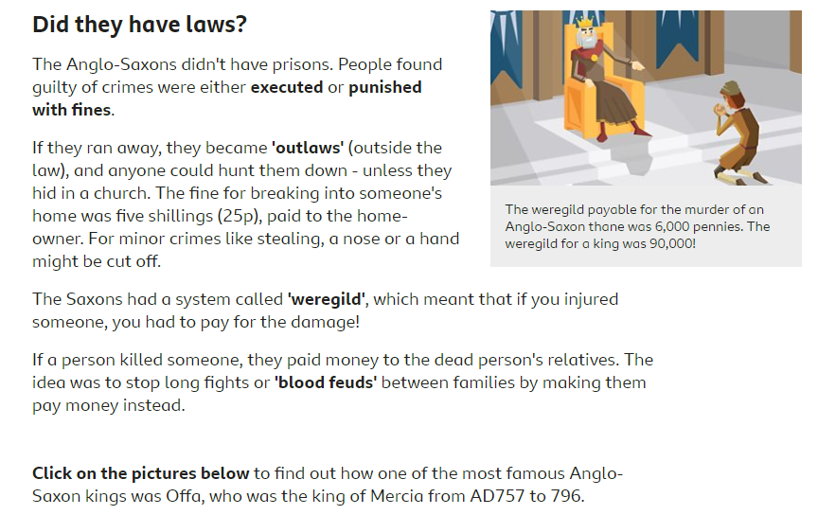

Task – Anglo-Saxon Wergild
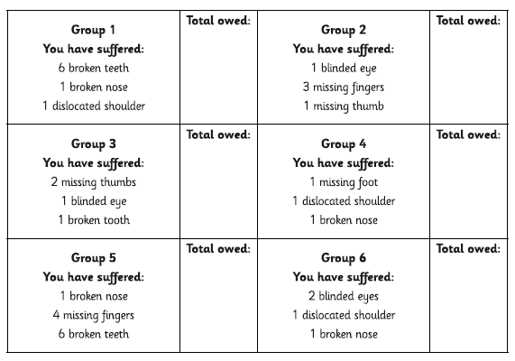
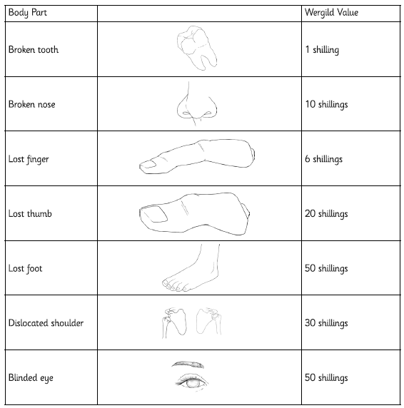
Look at the Wergild value for each body part and complete the ‘total owed’ below.
- What is similar about the way that the Romans and Anglo-Saxons carried out their punishments?
- What differences have you noticed?
(Hint: think about the trials by ordeal – who or what did the Anglo-Saxons believe was playing a part in deciding whether that person was guilty or not?)

Tudor Crime and Punishment
There were no police during the Tudor times. However, laws were harsh and wrongdoing was severely punished. In Tudor times the punishments were very, very cruel. People believed if a criminal’s punishment was severe and painful enough, the act would not be repeated and others would deter from crime as well.
Entertainment
A public execution was an event not to be missed and people would queue through the night to get the best places. There was always a carnival atmosphere and pie sellers, ale merchants and producers of execution memorabilia did a good trade.
How many people were executed (put to death) during the reign of Henry VIII?
Some 70,000 people suffered the death penalty during the reign of Henry VIII.
Punishment used during Tudor times,
if someone broke the law
Methods of execution
- Beheading ("Death by the Axe")
This was a punishment that resulted in your head being chopped off! The heads were sometimes placed on spikes along London Bridge or other places.
Beheading was considered less degrading than hanging, and it usually killed more quickly. Noblemen (rich) who committed crimes were more likely to be beheaded than hung.
- Hanging from the gallows.
A piece of rope was put around the neck making it hard for the person to breathe. The person would be hung from the rope until he/she had stopped breathing and was dead. People were hung for crimes such as stealing, treason, rebellion, riot or murder.
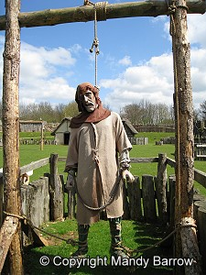
Hanging
- Burning
Women found guilty of either treason or petty treason were sentenced to be burned alive at the stake
- Being 'pressed' (crushed)
- Boiled alive
For attempting to murdering someone you could be boiled alive in a big bowl of hot water.
Lesser punishments for committing crime
included:
- Whipping (flogging)
Many towns had a whipping post. The victim was chained to the post, stripped to the waist and whipped.
You could be whipped for stealing a loaf of bread!
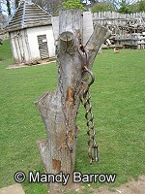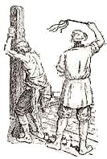
Whipping
- Branding with hot irons
Hot irons were used to burn letters onto the skin of offenders hand, arm or cheek. A murderer would be branded with the letter 'M', vagrants with the letter 'V', and thieves with the letter "T".
- The pillory (standing)
The pillory was a T shaped block of wood with holes for the hands in the crossbar of the T. The person being punished would have to stand in the device in the middle of the market to be ridiculed by passersby.
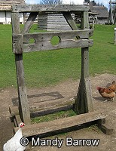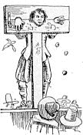
The Pillory
- The stocks (sitting)
Stocks were used in the same way as the pillory, except that with stocks, the feet were bound. The stocks were a block of wood with two holes for your feet to go in. Local people threw rubbish and rotten eggs at people in the stocks.
- The ducking stool (Punishment for women)
Accused witches were dunked into a river, to see if they were innocent or guilty. If they floated, they were considered guilty and burnt at the stake. If they sank, they were innocent but died anyway, by drowning. Either way, they perished.
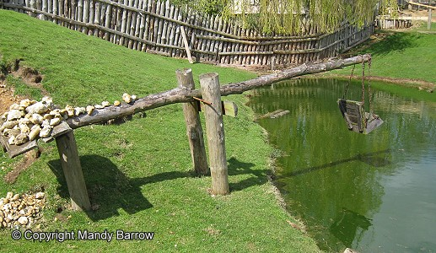
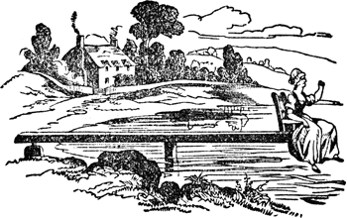
Ducking Stool
- The Brank, (the gossip's bridle)
The brank was a punishment enacted on women who gossiped or spoke too freely. It was a large iron framework placed on the head of the offender, forming a type of cage. There was a metal strip on the brank that fit into the mouth and was either sharpened to a point or covered with spikes so that any movement of the tongue was certain to cause severe injuries to the mouth.
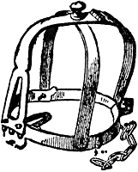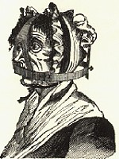
The Brank
- Limbs cut off
Some people who stole things from shops had their hands cut off.
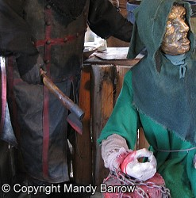
- The Drunkard's Cloak
This was a punishment for public drunkenness. The drunk was forced to don a barrel and wander through town while the villagers jeer at him. Holes were cut in the barrel for the person's hands and head, causing it to become like a heavy, awkward shirt.
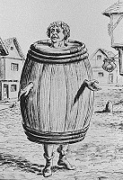
The Drunkard's Cloak

Task – Tudor Crime and Punishment

Cut the cards out and match the punishment to the crime.
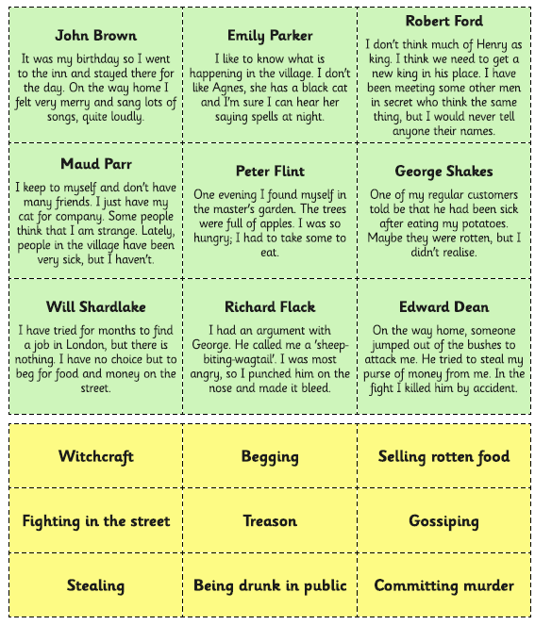
- Why was torture such a big part of the justice system in the Tudor period?
- What did the Tudors (mainly the rich and wealthy people) see as the most worrying crimes?
- Are there some punishments the Tudors use that haven’t changed since the Anglo-Saxon period?
- Is the Tudor justice system fair? Can you explain why you think this?

The Highwayman

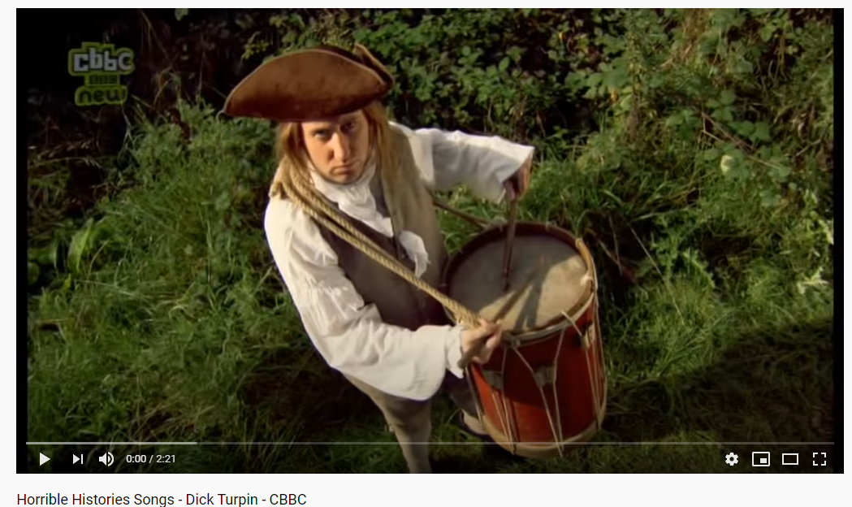
Watch this YouTube video https://www.youtube.com/watch?v=WYU-vSh7ORA
- Dick Turpin was born in the early 18th century as Richard Turpin.
- His father was John Turpin, a small scale farmer from Essex.
- It is thought that Dick Turpin was an apprentice butcher. He opened his own butchers shop after completing his apprenticeship.
- He began to steal livestock, but was caught trying to take two oxen and he was forced to flee.
- Dick Turpin became a member of the Essex Gang, a group of criminals who specialised in robbing farmhouses. Other members of the Essex Gang included: Thomas Barnfield, Ned Rust, John Wheeler and Herbert Haines.
- The Gang often tortured the inhabitants of the houses they broke into in an attempt to get them to reveal where their valuables were hidden.
- By 1735 a reward of £50 was offered for the capture of the Essex Gang. Two members of the groups were caught, but Dick Turpin managed to escape.
- Turpin began to work with Tom King (often refered to as Captain). They used to watch the roads through Epping Forest in Essex from their cave hideout. Once they had identified a suitable target, they would rob them. In 1737 a £100 reward was announced for the capture of Dick Turpin.
- An Essex gamekeeper called Morris managed to locate Dick Turpin’s base in Epping Forest. Turpin shot Morris.
- Dick Turpin killed Tom King by mistake. He was trying to stop King being arrested for collecting a horse that Turpin had himself stolen.
- Turpin realised he had to leave Essex and he decided to head for Yorkshire. He took the name John Palmer and he started to rob farmhouses and steal horses.
- After an unsuccessful attempt to steal some cattle, Turpin returned to the inn he was staying at and, in frustration, shot the landlord’s rooster. The landlord complained to Dick Turpin, and after Turpin threatened to kill the landlord, he was arrested.
- Turpin (as John Palmer) was held in the dungeons of York Castle and other charges against John Palmer were investigated.
- From prison, Dick Turpin wrote a letter to his brother. Unfortunately, for Turpin, his brother wouldn’t pay the postage owed on the letter and it was returned to the Post Office. One of Dick Turpin’s former teachers happened to see the letter at the Post Office and recognise the handwriting. The teacher was sent to York to identify Dick Turpin.
- Turpin was given the death sentence and he was executed by hanging in York. If accounts of his death can be believed, apparently Dick Turpin was incredibly courageous and chatted to the executioner before throwing himself off the ladder to his death.
- Since his death, the character and life of Dick Turpin has been romanticized and the idea of Dick Turpin as a ‘gentleman highwayman’ has emerged. In a novel by William Harrison Ainsworth, a Victorian novelist, called Rookwood Dick, Turpin was portrayed as a hero, when he was, in reality, a vicious criminal.

Read the sources below and complete the table after Source 6
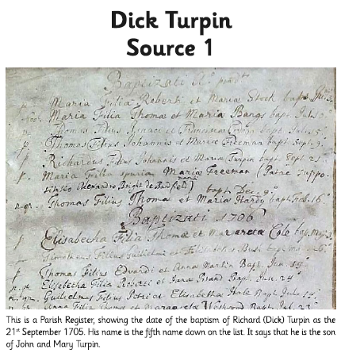

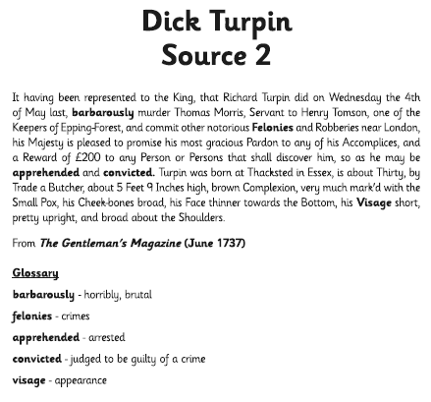
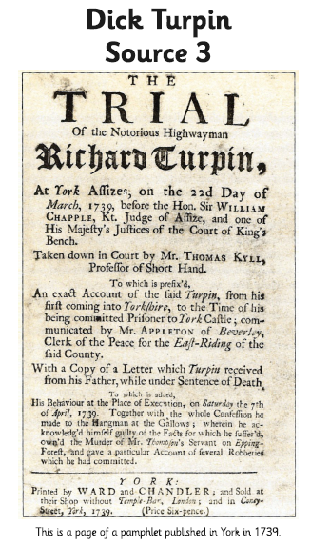
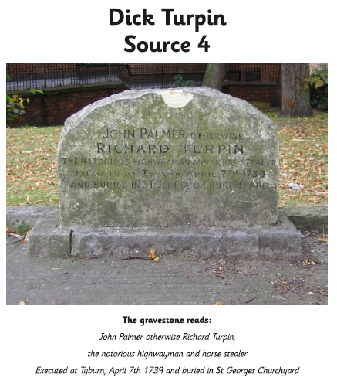

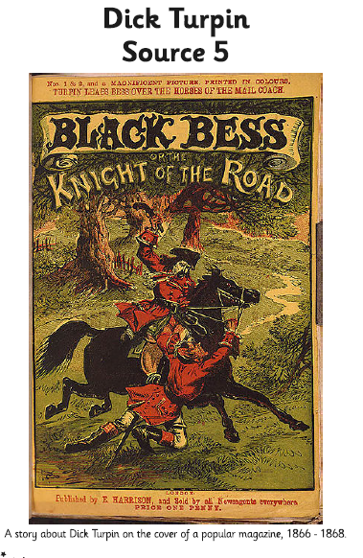

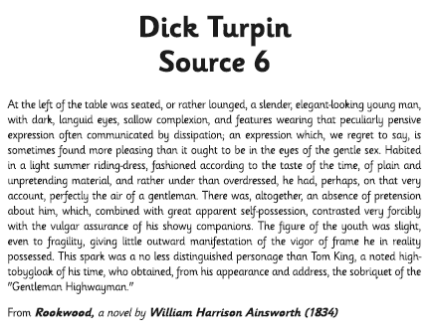

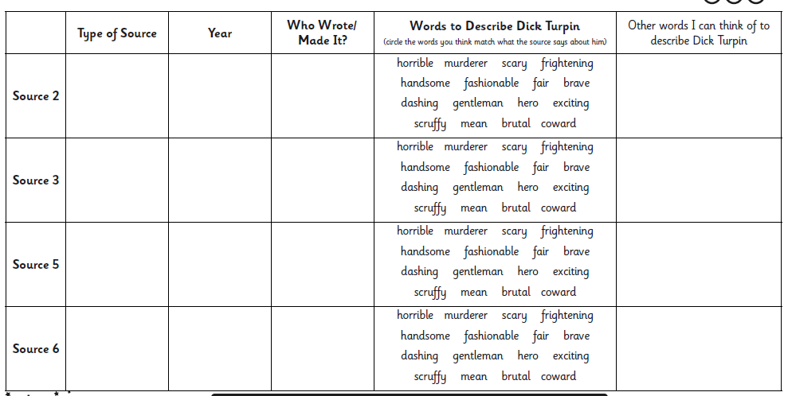
- Which sources make Dick Turpin look like a hero?
- Which sources make Dick Turpin look like a villain?
- Which do you think are more accurate? Can you explain your reasons why?
- Which do you think are probably not accurate? Why?
- Do you think that he was a villain or a hero? Why?

