All About the Number 9

Watch Numberblocks

<https://www.bbc.co.uk/cbeebies/watch/numberblocks-the-nine-song>

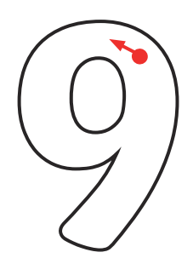

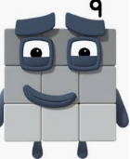

Can you count how many buns there are?

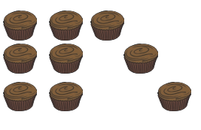

I am Numberblock number 9.

How many beads do we have?



Can you draw 9 dots on

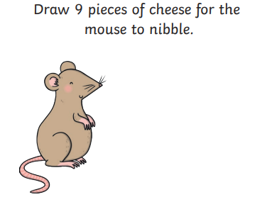

the tens frame?

|  |  |  |  |  |
| --- | --- | --- | --- | --- |
|  |  |  |  |  |
|  |  |  |  |  |

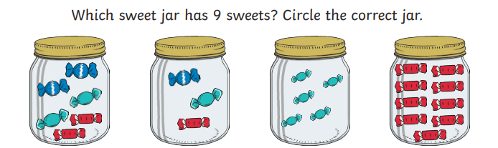

Can you write number 9?

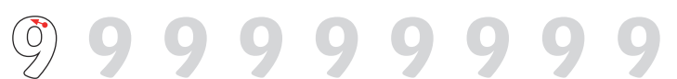

Which is the Odd One Out?

How do we know? Let’s Count.

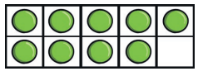 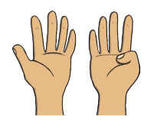 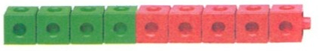

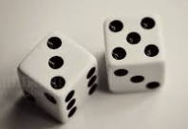 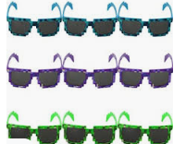 

Can you find 9 objects from around your home?

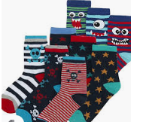 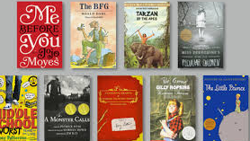

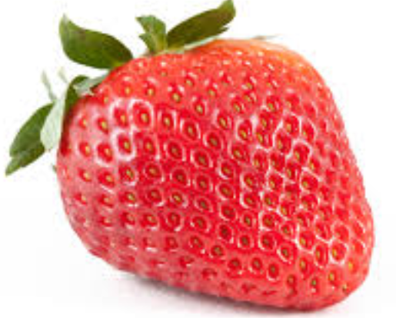 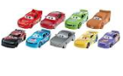



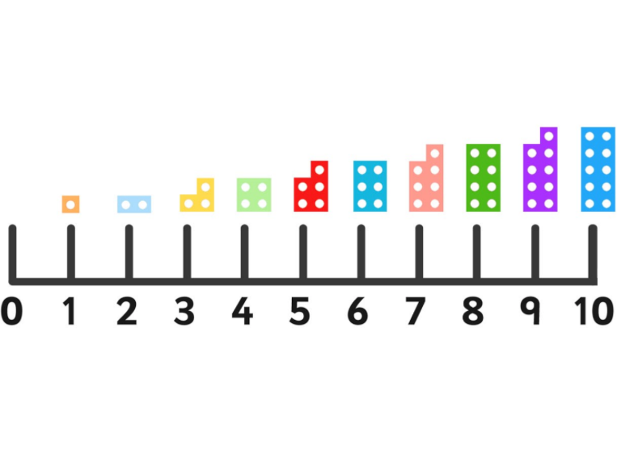Can you circle number 9?

What number comes after 9?

What number comes before number 9?

How many can you count?

Can you spot all the number 9s?

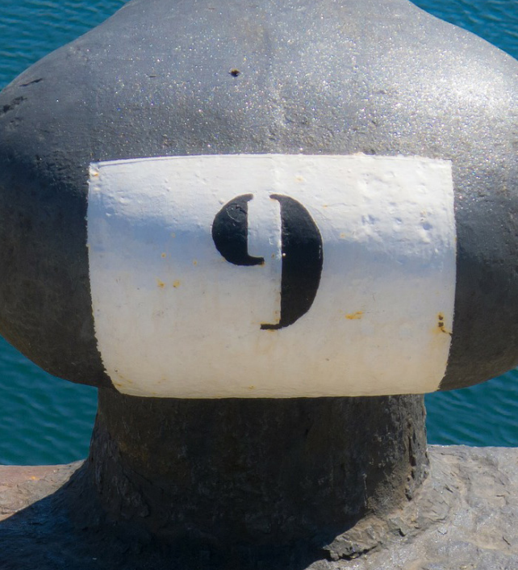 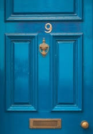 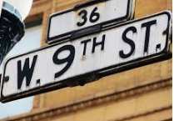

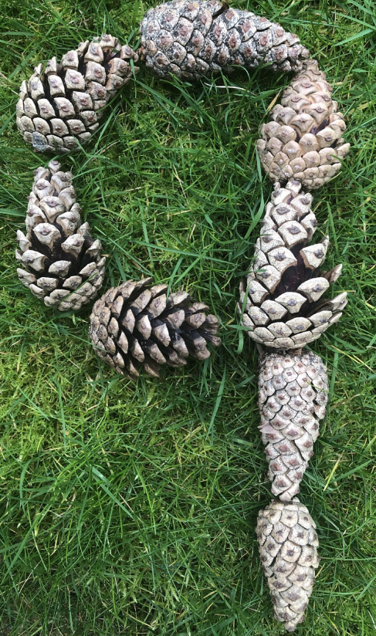 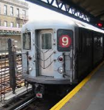 

How many counters are on the Tens Frames?

|  |  |  |  |  |
| --- | --- | --- | --- | --- |
|  |  |  |  |  |
|  |  |  |  |  |

|  |  |  |  |  |
| --- | --- | --- | --- | --- |
|  |  |  |  |  |
|  |  |  |  |  |

|  |  |  |  |  |
| --- | --- | --- | --- | --- |
|  |  |  |  |  |
|  |  |  |  |  |

|  |  |  |  |  |
| --- | --- | --- | --- | --- |
|  |  |  |  |  |
|  |  |  |  |  |

|  |  |  |  |  |
| --- | --- | --- | --- | --- |
|  |  |  |  |  |
|  |  |  |  |  |

|  |  |  |  |  |
| --- | --- | --- | --- | --- |
|  |  |  |  |  |
|  |  |  |  |  |