All About the Number 8

Watch Numberblocks

<https://www.bbc.co.uk/cbeebies/watch/numberblocks-the-eight-song>

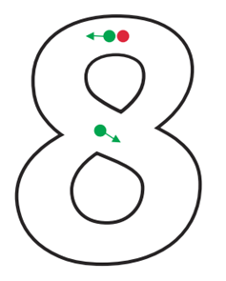

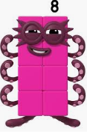

Can you count how many spiders there are?

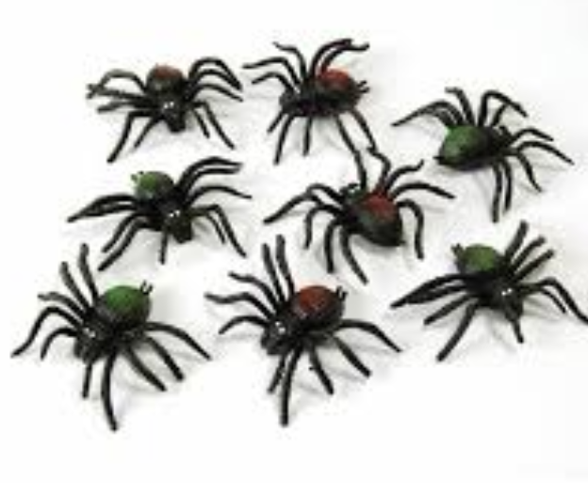

I am Numberblock number 8 .

How many cubes do we have?

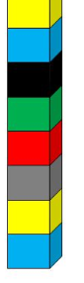

Can you draw 8 dots on

Can you count how many fish are in the water?

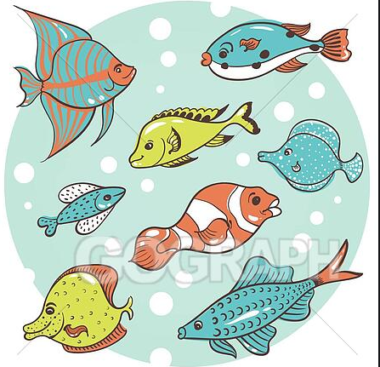

the tens frame?

|  |  |  |  |  |
| --- | --- | --- | --- | --- |
|  |  |  |  |  |
|  |  |  |  |  |

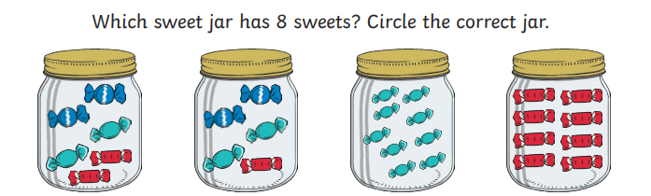

Can you write number 8?

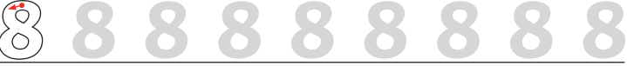

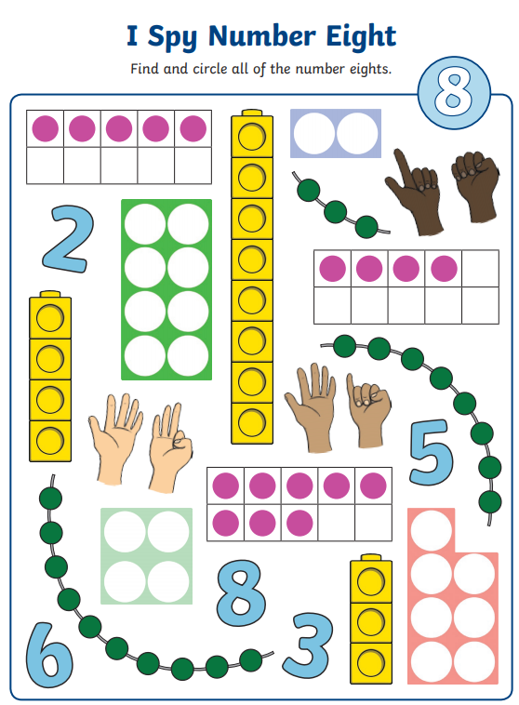 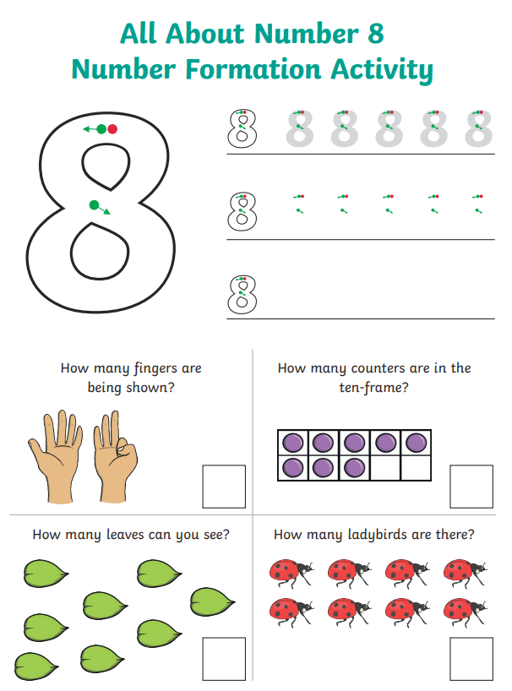

Which is the Odd One Out?

How do we know? Let’s Count.

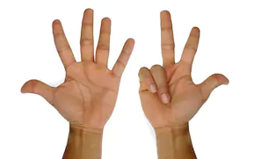  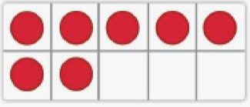

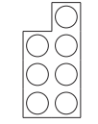 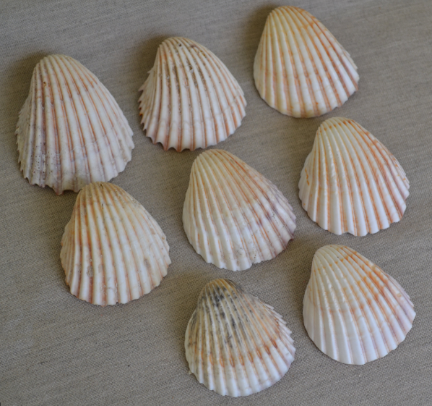 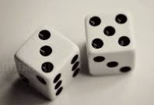

Can you find 8 objects from around your home?

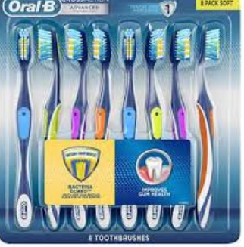 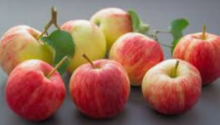

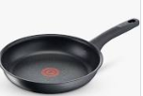 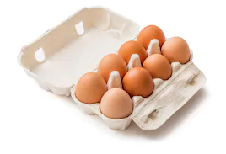



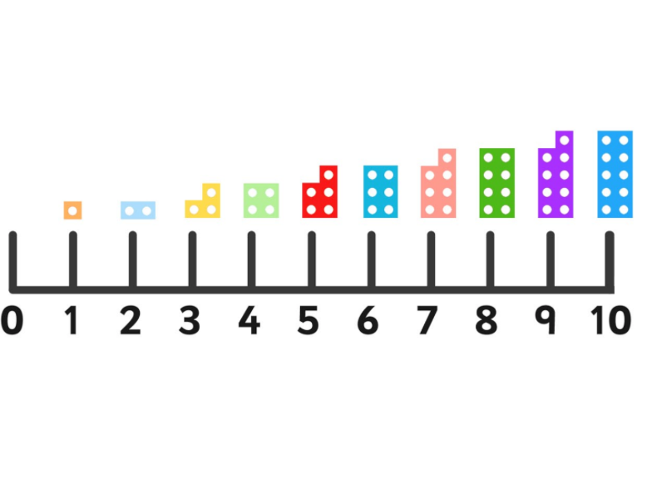Can you circle number 8?

What number comes after 8?

What number comes before number 8?

How many can you count?

Can you spot all the number 8s?

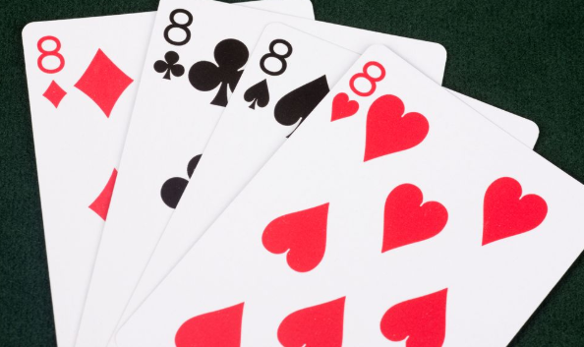 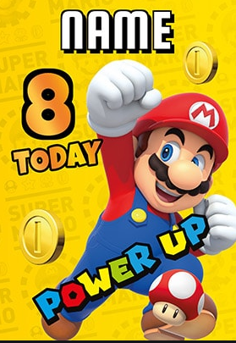 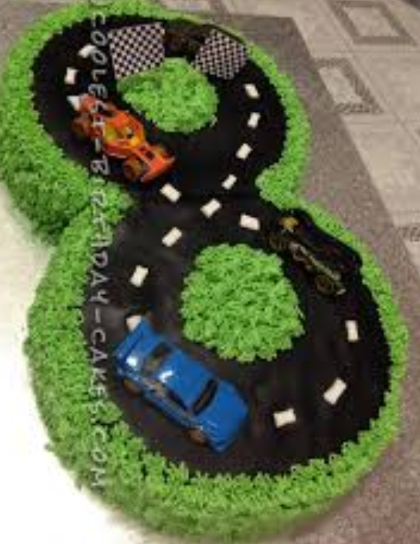

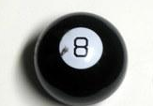 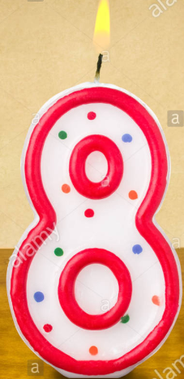 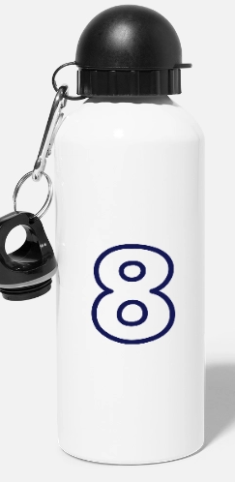

When you go on a walk see if you can spot any number 8s.

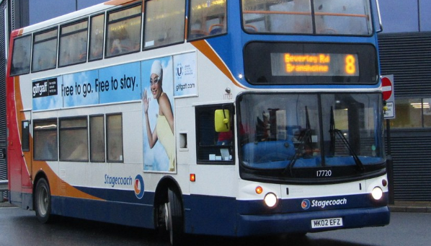 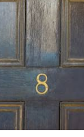 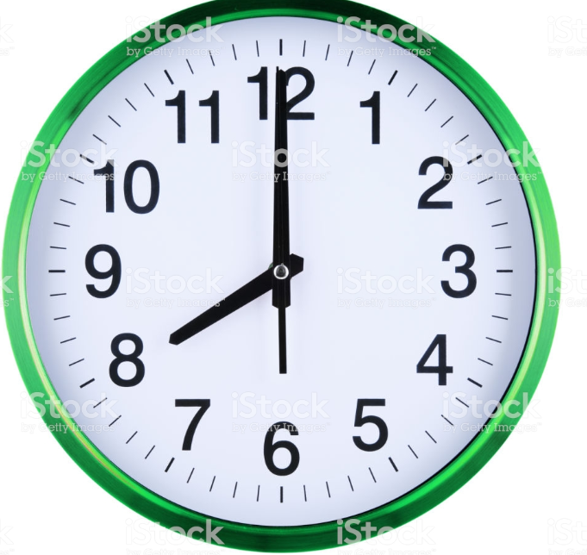

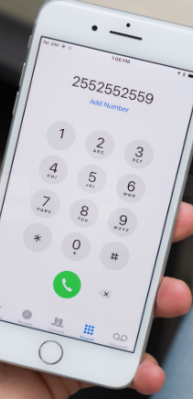 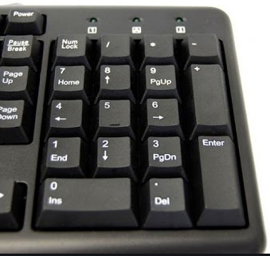

How many counters are on the Tens Frames?

|  |  |  |  |  |
| --- | --- | --- | --- | --- |
|  |  |  |  |  |
|  |  |  |  |  |

|  |  |  |  |  |
| --- | --- | --- | --- | --- |
|  |  |  |  |  |
|  |  |  |  |  |

|  |  |  |  |  |
| --- | --- | --- | --- | --- |
|  |  |  |  |  |
|  |  |  |  |  |

|  |  |  |  |  |
| --- | --- | --- | --- | --- |
|  |  |  |  |  |
|  |  |  |  |  |

|  |  |  |  |  |
| --- | --- | --- | --- | --- |
|  |  |  |  |  |
|  |  |  |  |  |

|  |  |  |  |  |
| --- | --- | --- | --- | --- |
|  |  |  |  |  |
|  |  |  |  |  |