Tricky Word Splat

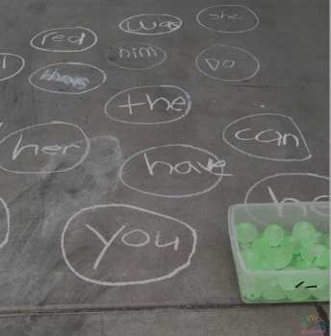

1. Write some tricky words on the ground.
2. Child to read the word and throw a water balloon if they correctly read it..

Words:

I the my to go of his she he

you said will was with be