Subtraction

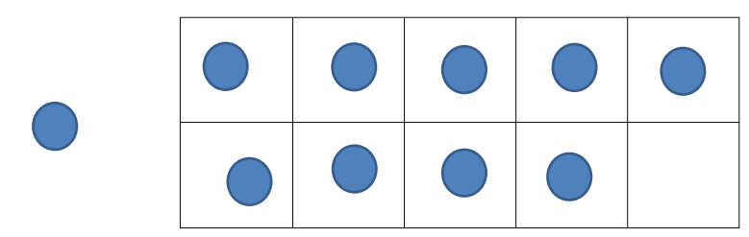

This is called a tens frame. Your child should be familiar with these as we use them frequently in school.

1. You can create your own by folding an A4 piece of paper into 10 squares or draw one.
2. Use counters, sweets or 1p coins and place one in each square.
3. Practise lots of subtraction within 10 by taking a number of objects off the tens frame.
4. Can your child write it in a number sentence, for example, 10-9=1.
5. Once your child is confident, try two tens frame with the same concept as before but now within 20.