Special Friends Snap

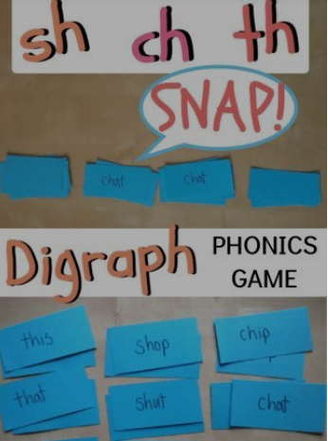

1. Write some words containing special friends (sh, ch, th, nk, ng, oq, oo, ar, or, ir etc.)
2. Create two piles of word cards and share them out.
3. Play snap but instead of the word being the same, it will only be snap if it has the ‘special friends’.