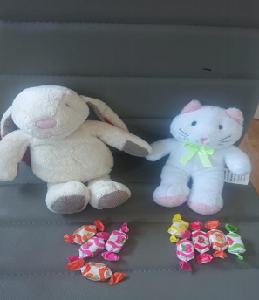

1. You will need two teddy bears, dolls or figures. Use sweets biscuits or anything you have enough of to share out.

2. Before introducing sharing using the bears. Explain to your child that we have bought the teddies a treat but we need to share them out

3. Say to child bear would like 4 sweets

4. Allow your child to count out 4 sweets (or a number of your choice)

5. Then ask your child to give the other bear 5 sweets (or number of your choice)

6. After the bears have their sweets ask your child who has the most and who has less

7. Ask your child how many altogether.

8. Ask your child if it is fair if one has 6 and the other has 5? What does fair mean? Share something out between you and your child. Make sure it’s obviously not fair, for example, 10 for you and 4 for your child. Wait and ask your child if it’s fair. Question why it isn’t and how would we make it fair?

9. At this point make sure you have an even number of sweets/ objects you are sharing out. Ask your child to share them equally between the two bears. This could be one for you, one for you etc. or using their knowledge of numbers to know how many it would be. For example if you have 8, double 4 is 8.