Jigsaw Topic Tasks

Task 1
Talk to somebody at home about how you felt during the lockdown period. Share how you are feeling now and discuss your thoughts about going back to school. Complete the ‘task 1’ worksheet to express your feelings using words and pictures.

Task 2
Read through information on the coronavirus comic posters below. Highlight ways in which you can keep safe and help stop the spread of the virus. Fill in the thought clouds on the ‘task 2’ worksheet to note down things you can do to keep yourself and others around you safe.
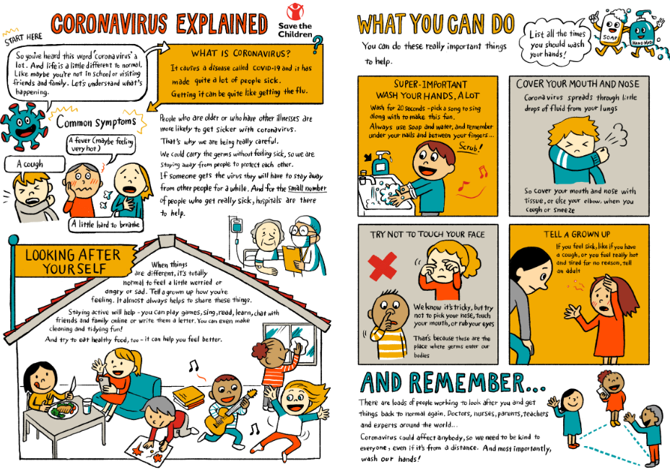

Task 3
Think about all the things that you do and say to be a good friend. Think about friendships that you have at home and at school and what you like about them – why are they special? Have a look at the ‘task 3’ worksheet and complete the task to create your own poem.

Task 4
Talk with an adult about your feelings and emotions that you have been feeling during the Coronavirus pandemic. Complete the ‘task 4’ worksheet to review any worries or concerns that you may have and to talk about how you can overcome these.

Task 5
Think about all the positive memories you have about the current school year. Think about all the things you have learnt and enjoyed doing at school before the school closure. Complete the ‘task 5’ worksheet to design your own t-shirt to reflect upon these moments and find out what you’re looking forward to for your next school year.

Jigsaw Task 1
LO: I can express my feelings using words and pictures.

Words to describe my feelings when in lockdown: | Words to describe my feelings about going back to school:
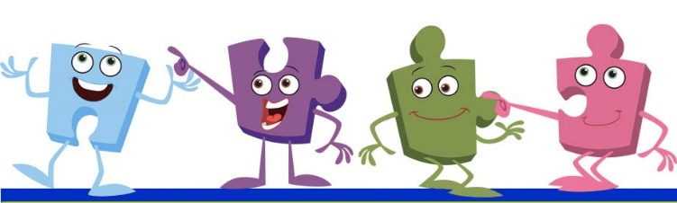

A drawing to show my feelings when in lockdown: | A drawing to show my feelings about going back to school:

Jigsaw Task 2
LO: I know how to keep myself and others safe to stop the coronavirus spreading.

Jigsaw Task 3
LO: I know how be a good friend and enjoy my friendships even though we have to play differently at the moment.
Have a go at creating your own poem to express friendship during Covid 19.
What does it means to you? What have you missed? What do you enjoy and value about friendship? What are you looking forward to when social distancing is lifted?

Jigsaw Task 4
LO: I can identify my worries and fears and how I can help myself.

Note down some feelings and emotions that people may have been feeling during the Coronavirus pandemic.

Colour in the traffic light image below.

- Next to the green light, write something you can start to do to help manage difficult feelings.
- Next to the amber light, write something that you may continue to do to help manage difficult feelings.
- Next to the red light, write something that you will stop doing as it makes difficult feelings worse.

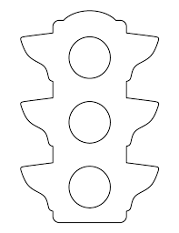

Do you know anyone who can help? Who can help you in school and at home?

_________________________________________________________________________________

Jigsaw Task 5
LO: I know how to prepare myself emotionally for the changes next year.

Think about positive memories about the current school year. Design a t-shirt that reflects these moments on the BACK. On the FRONT, design something that reflects what you are looking forward to about your next school year.

