Pop-up Pirate Phonics

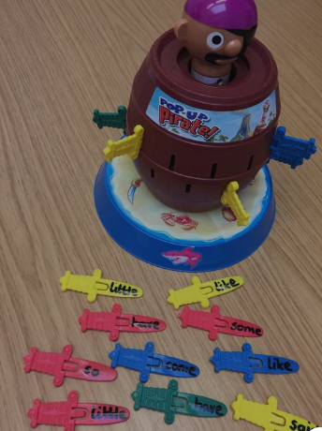

1. Write some words using the sounds that your child has been learning in phonics on the swords.
2. Ask your child to sound out the word before placing the swords into the pirate.
3. You could even try this with tricky words.