Pack 9 and 10 – Wider Afternoon Curriculum

'Magic, Mystery and Mayhem'
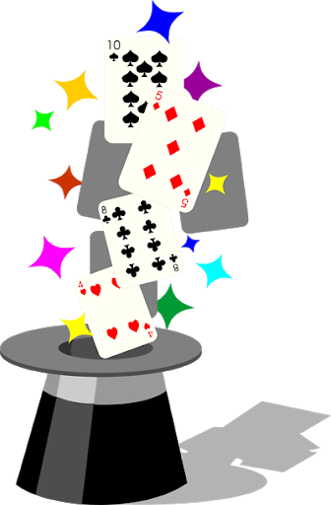

Please share your activities on Twitter @RokebyPark #rokebyparkhomelearning
 | Suggested Activity
1 | Science: Make your own potion!  Can you look in your garden for some ingredients (leaves, petals, twigs) for your potion?  Check with a grown-up if it is okay for you to take them from your garden.  If you don't have a garden or can't access the outdoors - can you use some arts and crafts materials to make your potion? (e.g. glitter, play-doh, stickers)  Write a recipe for your potion:  e.g. First a get a tub.  Next add five leaves to the tub.  Then sprinkle seven petals into the potion.  Write down what your potion does when you cast a spell.  Extension: Can you make a magic wand to use with your new spell?
2 | Music: Listen to music from these magical films.  1. Harry Potter  https://www.youtube.com/watch?v=Htaj3o3JD8I  2. Fantasia  https://www.youtube.com/watch?v=QziztOCcKOk&list=PLWAb6uoo1Jl9k7McxMEf2xBlUmNTR81ZX&index=6  3. The Sword in the Stone  https://www.youtube.com/watch?v=Tb75RjpvBIk  4. Bed Knobs and Broomsticks  https://www.youtube.com/watch?v=ezenR3Cljyo  Listen to each piece of music (try not to watch the video the first time - just listen). Talk about each one:  1. What do you imagine when you listen to this song?  2. What instruments can you hear, if any?  3. Do you like or dislike this piece of music? Why?  Can you make up your own piece of magical music and perform it to someone in your house
3 | Design and Technology:  Winnie the Witch has lost her hat!  Can you design a new hat for Winnie? Be creative!  What shape could it be?  Does a witch's hat always need to be pointy and black?  What could it be mad from?  How about a 'spring themed' hat?  Or one made from chocolate? Would that be useful?  Draw a picture of it and label the different parts.
4 | Design and Technology:  Can you make Winnie the Witch a hat from recycled materials?  Use your imagination and get creative!  Could you use recycled items and things you already have?  Rememeber to ask for a grown-up's permission.  Ask for help with cutting out too.  Is the hat you made like your design or is it different?  Tell a grown up:  - What do you like about your finished hat?  - What would you change if you made it again?  - What did you enjoy doing when you made your hat?  - What did you find tricky?  - What materials did you use?  Post a picture of your hat on the school's Twitter @RokebyPark #rokebyparkhomelearning
5 | Geography:  Last week a witch from Room on the Broom lost her items around the UK.  She lost her cat in Scotland and her frog in England. She lost her wand in Wales and her cauldron in Northern Ireland.  Label the countries on the map below.
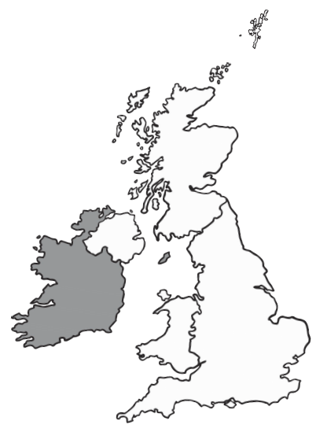
6 | Geography:  With a grown up, write simple instructions about how to find the witch's items using the vocabulary north, south, east and west.  e.g. First fly north to Scotland to find the cat.  Can you then draw each item in the correct country?

