How to make a drum
1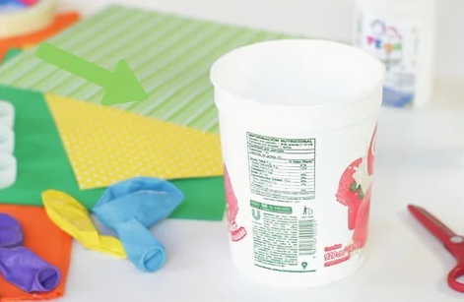
Find a pot to use. Find an old pot to use as the body of the drum. A pot with a diameter of less than 12 inches works best

2
Get the right size balloon. The balloon is going to be the head of the drum so it needs to be tight but large enough to fit around the top of the pot. If the balloon is too small, it might be too tight ad break when you drum.[1]
- A 24 inch balloon works best for pots 10 to 12 inches in diameter.
- A 16 inch balloon works best for pots under 10 inches in diameter

3 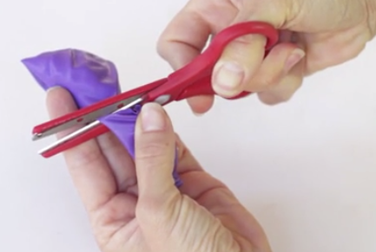
Cut off the mouthpiece of the balloon. Use scissors to cut the mouthpiece off of the balloon. Make sure you only cut the mouth piece and not the body of the balloon

4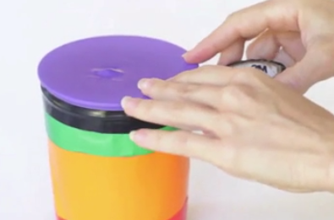
Stretch the balloon on the pot and secure it. Secure the pot in between your knees or ask a friend to hold it securely. Put the balloon over one side of the pot and carefully stretch it over the entire top of the pot. Secure the balloon on the pot by stretching several rubber bands onto the pot sitting on top of the balloon

5
Play your drum. Use lightweight wooden sticks to play your balloon drum. Chopsticks, small wooden dowels, or pencils work great for drumming on a balloon drum

