**How to Keep Healthy**

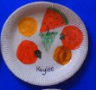 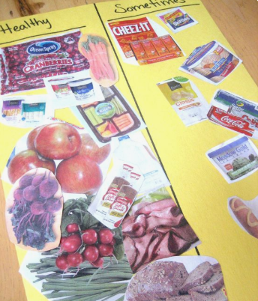

* Talk to your child about food that is healthy and unhealthy.
* What makes something unhealthy?
* Why is eating a lot of unhealthy food not good for our bodies?
* What is healthy to eat and why?

Using real food items from your house, magazines or you could even draw food items, sort them into healthy and unhealthy. Talk about the unhealthy food items being ok to eat in moderation. You could even create your own healthy plate of food.