**Extra Maths**

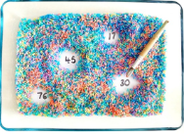 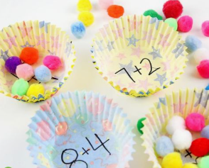

Write some addition and subtraction number sentences inside some bun cases. Demonstrate using pomp oms, buttons or anything small you have at home to add/ subjects to find the total.

Write numbers to 20 on a piece of paper. Put the paper in a shallow dish or on a tray and cover it with Hundreds and Thousands, glitter or salt. Your child needs to uncover the hidden numbers and tell you what they are.