All About the Number 6

Watch Numberblocks

<https://www.youtube.com/watch?v=g6oeLjnM8Cw>

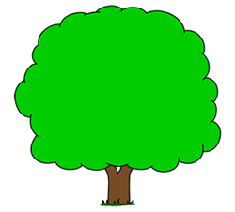

Draw 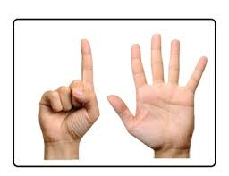apples on the tree.

Insects have 6 legs. Can you draw legs on the ant.

Can you draw 6 dots on the tens frame?

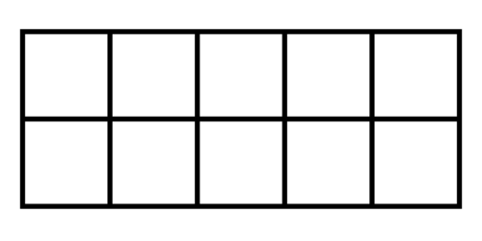

*Which dice shows*  *spots?*

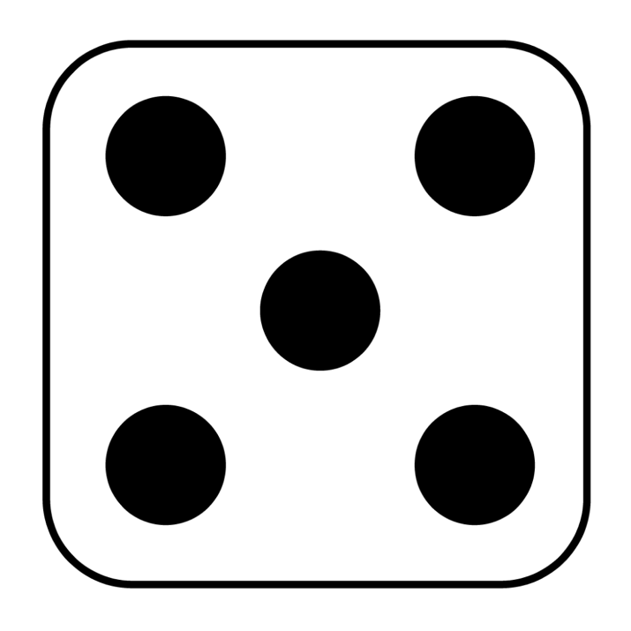

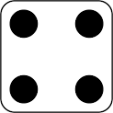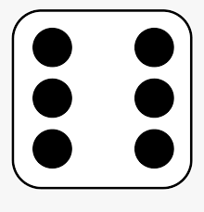

Can you draw 6 spots on the dice?

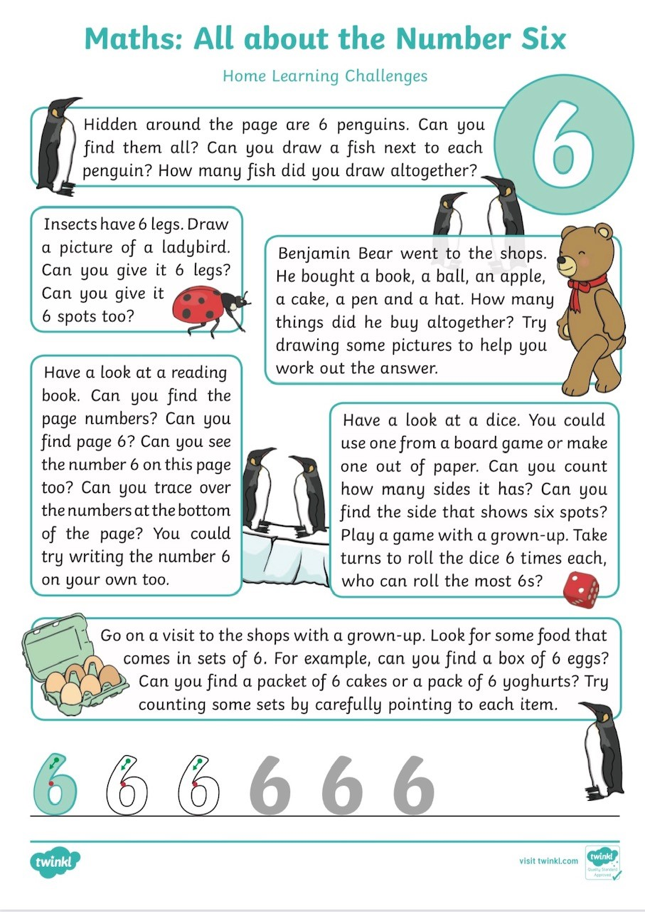

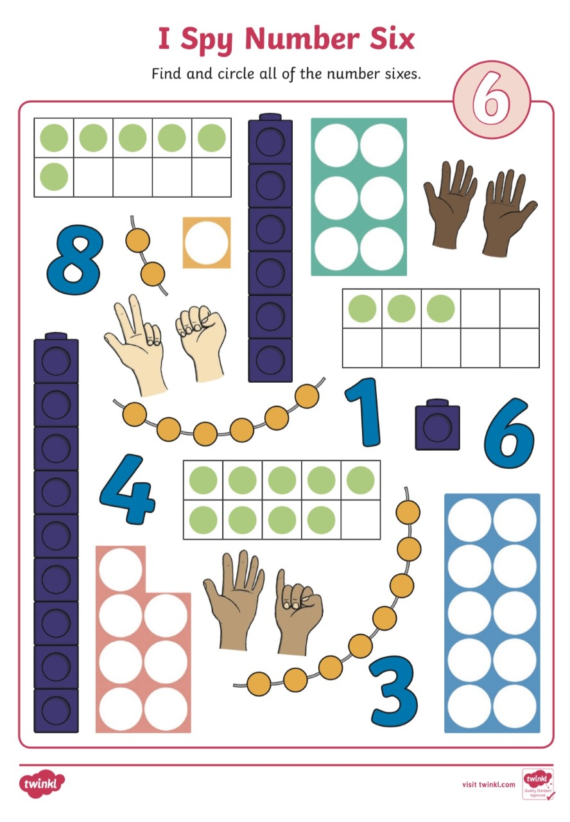

Which is the Odd One Out?

How do we know? Let’s Count.





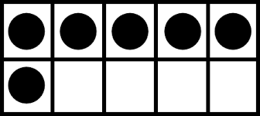

Which is the Odd One Out?

How do we know? Let’s Count the Legs

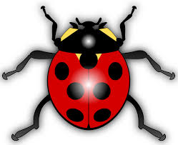

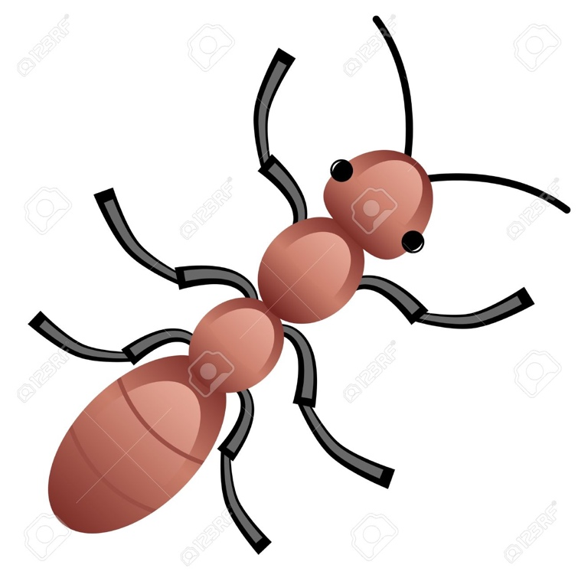

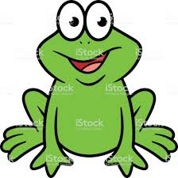

Can you find number 6 on the number line?

What number comes before 6?

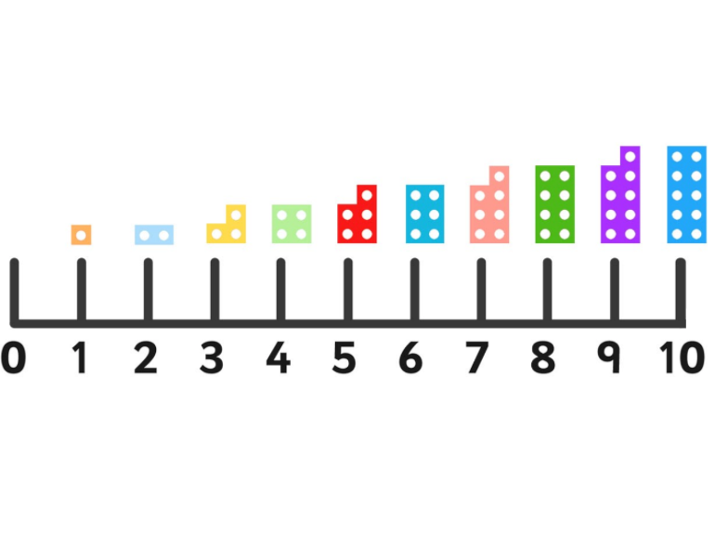What number comes after 6?

This shape is called a Hexagon. It has 6 sides. Can you count the sides?

Can you make a hexagon using sticks or lollypop sticks? How many will you need to count?

Can you find all the number 6’s?

